We have employee_details and employee_expenses files. Use local mode while running Pig and write Pig Latin script.

1. Top 5 employees (employee id and employee name) with highest rating. (In case two employees have same rating, employee with name coming first in dictionary should get preference)

STEP 1: LOAD “employee_details” FILE

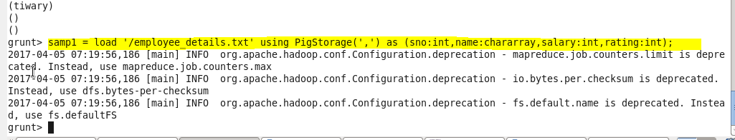

STEP 2: ORDERING OF DATA BASED ON “RATING “ IN DESCENDING ORDER TO GET THE HIGHEST RATING

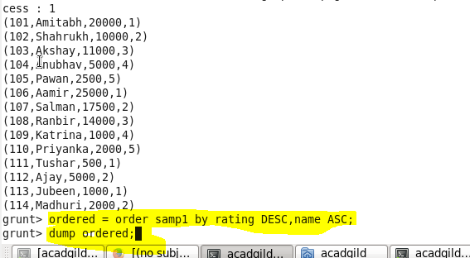

STEP 3: LIMITING THE DATA TO TOP 5 RECORDS IN ALPHABETIACL ORDER N HIGHEST RATING

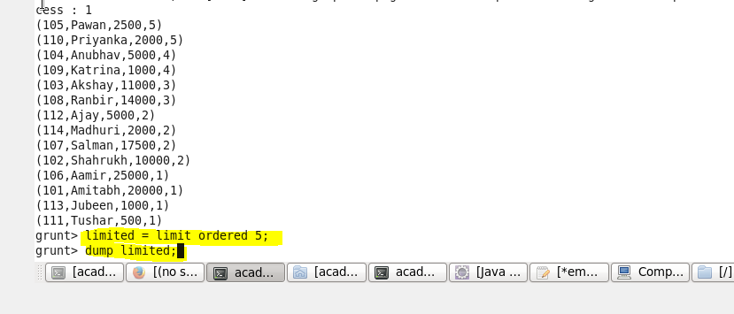

STEP 4: USING FOREACH COMMAND TO DISPLAY ONLY “SNO AND NAME “ COLUMNS

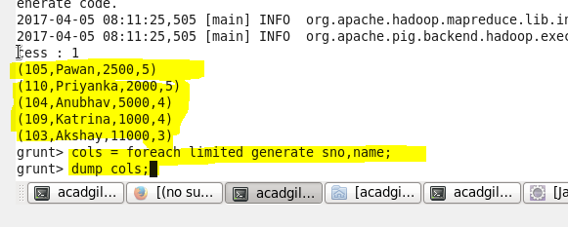

STEP 5: FINAL OUTPUT SHOWING TOP 5 RATING IN ALPHABETICAL ORDER

WITH SNO AND NAME FIELDS

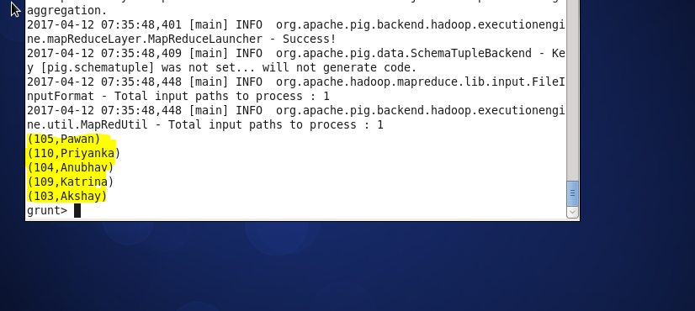

1. Top 3 employees (employee id and employee name) with highest salary, whose employee id is an odd number. (In case two employees have same salary, employee with name coming first in dictionary should get preference)

STEP1: LOAD "employee_details" File In It



STEP2 : USE “SPLIT COMMAND” FOR GETTING ONLY ODD NUMBERED “SNO” IN EMPLOYEE

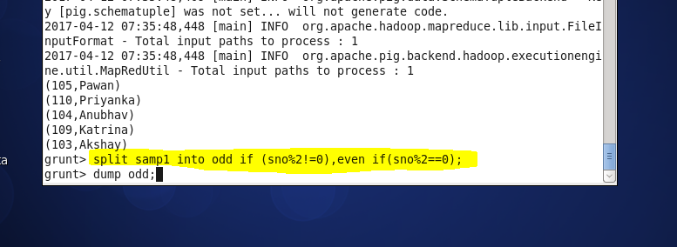

STEP 3: ORDER THE DATA IN ORDER OF HIGHEST SALARY ANDV ALPHABETICAL ORDER OF NAMES

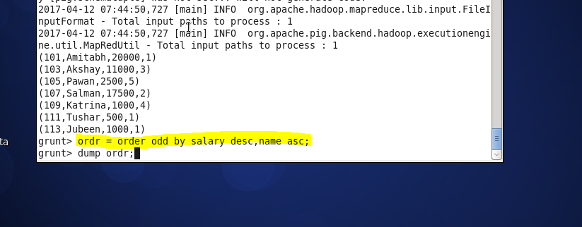

STEP 4: LIMIT THE DATA TO 3 RECORDS FROM EMPLOYEE

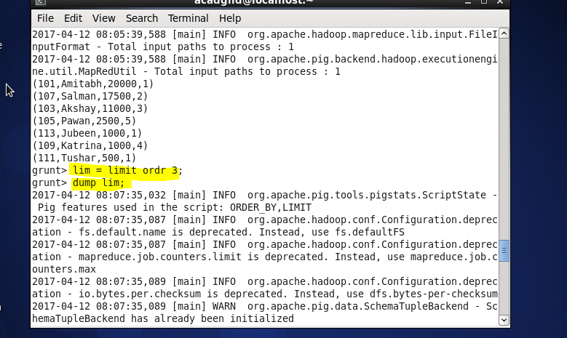

STEP 5: USE “FOREACH COMMAND” TO GET ONLY “SNO,NAME” FIELDS

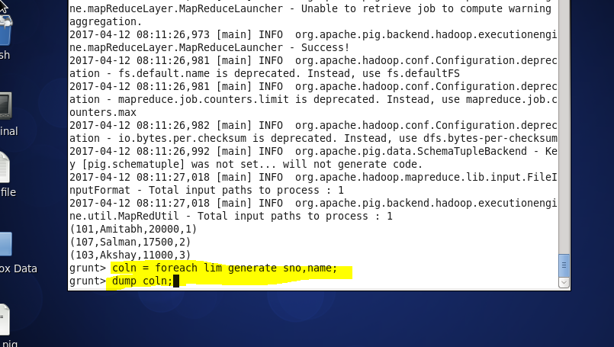

STEP 6: OUTPUT SHOWING “SNO,NAME” OF 3EMPLOYEE S WITH HIGHEST SALARY

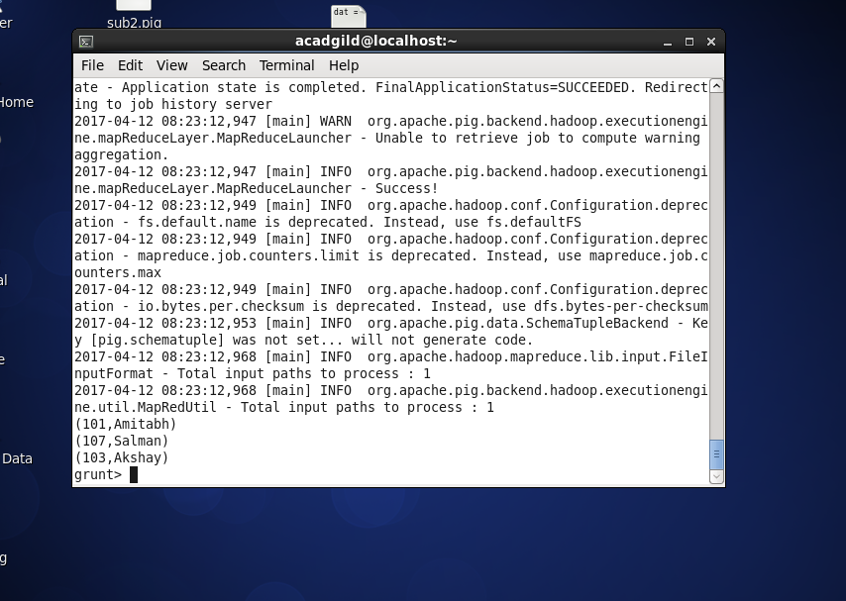

1. ) Employee (employee id and employee name) with maximum expense (In case two employees have same expense, employee with name coming first in dictionary should get preference

STEP 1: LOAD THE DATASET "employee_expenses"

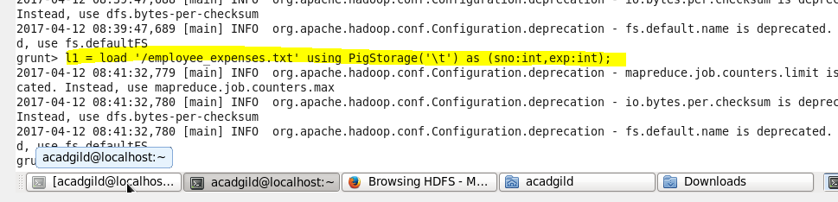

STEP2: JOIN THE 2 DATASETS AND PERFORMING ORDERING BASED ON HIGHEST EXPENSES

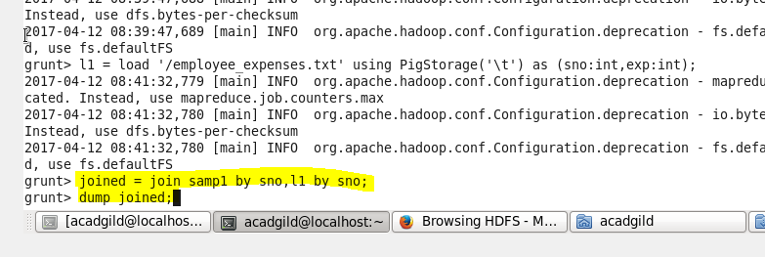

STEP 3: LIMIT THE DATA TO ONE RECORD USING LIMIT COMMAND

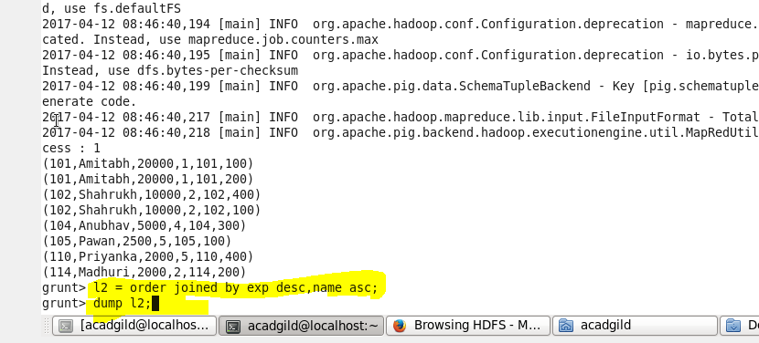

STEP 4: USE limit COMMAND TO PRINT ONLY SNO AN NAME OF EMPLOYEE WITH HIGHEST EXPENSE

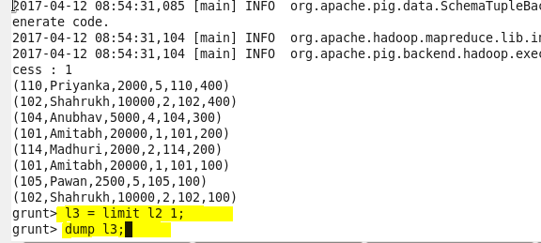

STEP 5 : OUTPUT

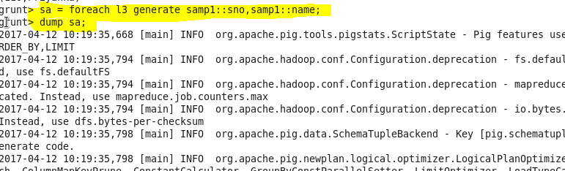

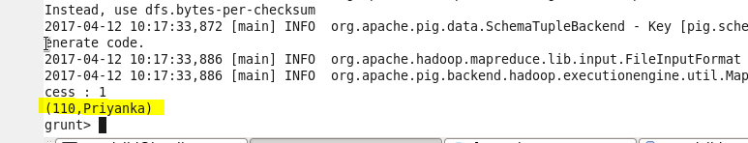

1. List of employees (employee id and employee name) having entries in employee_expenses file.

STEP 1: PERFORM SELF JOIN FOR 2 DATA SETS



STEP 2: USE FOREACH FOR DISPLAYING SNO AND NAME OF EMPLOYEES HAVING ENTRIES IN EXPENSE

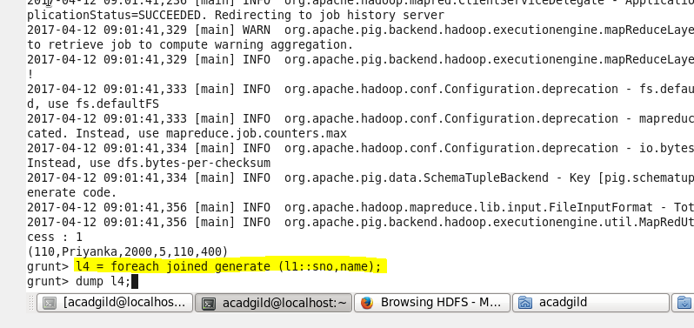

STEP 3: OUTPUT

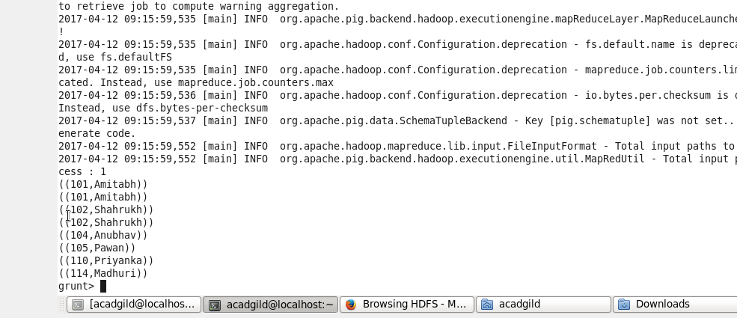

(e) List of employees (employee Id ) having no entry in employee_expenses file.

STEP 1 : use full join on employee_details and by sno on employee_expenses

* filter by leaving out null values in the above relation to eliminate entries from expenses

* use foreach to generate sno,name

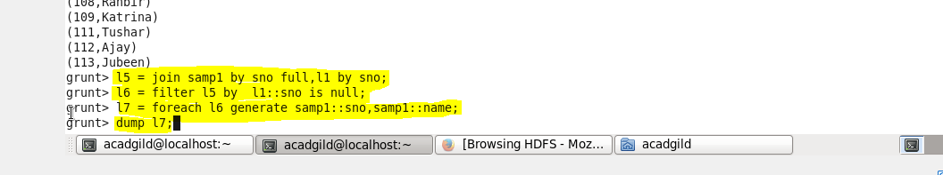 STEP 2: output

